For the 3rd point under task 1, list the data analytics framework only from the module material. And for the rest of the point; like point 2 in task 1 and points 1 & 2 in task 2, again do them after reading and understanding the module material only.

# Introduction & Project Plan

The ultimate goal of every marketing strategy is to boost brand awareness and promote the business’s products and services. It reaches out to the niche audience and engages with the consumers strategically. Marketing offers dynamic ways of influencing consumer behaviour and buying patterns positively (Jones *et al.*, 2008). However, the impact of such strategies is what truly matters; this is where marketing analysis comes to play. It scrutinizes the results of strategies, offers insights about the target market and improves on them.

Bangles International Jewellery (BIJ) is an up-and-coming luxury goods company that has demonstrated potential and promise in its field. Presently, BIJ operates across Asia, North America and Europe through distributors, concessions and signature stores. As part of its marketing strategy, the company invested in a marketing campaign in the UK in May 2020. This report aims to answer the following core business question:

**Did the marketing campaign have a positive impact on sales performance in the UK?**

To do so, three data analytic frameworks were considered:

1. **Descriptive analytics** - which focuses on providing objective and sensory data that is statistically reliable and analysable (Kemp, Hort and Hollowood, 2018). It utilizes traditional technologies such as histograms and graphs to compile and summarize raw data.
2. **Predictive analytics** - primarily provides information on what *will* happen in your business. It utilizes business intelligence technologies to unveil relationships within large data to predict future behaviour and events (Eckerson, 2007).
3. **Prescriptive analytics** - in addition to data, it also provides information on what will happen and suggestions on how to better it. It incorporates artificial intelligence and sophisticated algorithms to provide optimal and customized decisions (Lepenioti *et al.*, 2020).

After thorough deliberation, the prescriptive analytic framework was chosen to analyse the data. It is a pioneer in the realm of business analytics and utilizes high-end technology to maximize business opportunities (Soltanpoor and Sellis, 2016). While descriptive analysis focuses on the past and predictive analysis elaborates on the future, prescriptive analysis employs the past to better the future directly. Going beyond data analysis, it enables efficiency and lessens costs. Its automated feature is utilized by several companies presently to make decisions in real time. Artificial intelligence and machine learning are commonly used to enable computers to make decisions. The plethora of information offered by prescriptive analytics will be utilized to nail down not only whether the campaign positively impacted the UK, but also what could be done to make it better and how to go about it in the future.

This report initially highlights the issues that are commonly encountered by analysts and raises the issues found within the data provided by BIJ. It proposes a solution on how to address the same. Subsequently, the numerical data collected will be thoroughly analysed and investigated. Inferences and conclusions are drawn from the data and noted. These findings will be presented through visual presentations to promote a better understanding. Finally, the analysis and conclusions inferred are detailed and recommendations based on the same are shared.

BIJ has stated its ambition in competing against established companies such as Cartier and Signet. Although there exists a significant way to achieve the same, their milestones may be considered the Key Performance Indicators (KPI) for BIJ. Often considered navigational instruments by managers, they highlight where the company is lacking (Marr, 2012). KPIs are backed by analytical data and are established by it. By improving the analysis obtained, Key Performance Indicators grow loftier and enables better result in the future. Thus, the need and focus on analytics.

# Data Quality Issues and Remedies

Although present data acquisition is concluded through modern technologies, there still exist data quality issues that plague data analysts. This leads to ignorant decision-making and inaccurate analyses. Identifying and rectifying such faulty data makes accurate and precise data will be available. Common data quality issues and how to resolve them are listed below:

## Common Data Quality Issues

1. **Data Duplication**

One of the most widespread data quality issues, data duplication is often unnoticed. It usually occurs when data is collected by multiple people and/or departments and a lack of coordination. As the dataset grows larger, the potential for duplication and its impacts grows dire. It leads to a wastage of manpower, and time and results in increased costs for the business among other things.

Despite the severity, the solutions are fairly simple. Excel provides an option to remove duplicates, although it does not provide a record of the deleted items. Businesses commonly opt for the usage of tools such as Microsoft Dynamics 365 Business Central to eliminate duplication through departmental integration.

1. **Missing Data**

Missing data may be sorted into three types: missing completely at random (MCAR), missing not at random (MNAR), and missing at random. (MAR). To ascertain the missing data and how to resolve it, it is necessary to determine the type.

The treatment for missing data varies between data types. When dealing with MCAR or MAR values, the missing values may be left as is - especially if it is a small sample. Deletion of the values in their entirety and imputation i.e. replacing the missing value with a reasonable estimate, are also widely used.

1. **Drastic changes**

This issue is more commonly noticed and resolved within smaller samples. It refers to data that stands out as odd and strange within the rest of the dataset. It usually stems from incorrectly entered data and errors. Although there are instances when such drastic changes are accurate, they must nonetheless be verified.

Reconciliation frameworks and data tools may be used to identify this issue and resolve it.

1. **Default Values**

Usually, a by-product of missing values, default values are preset values that are automatically placed when there is a lack of documentation. Usually, these values are used by en

The best way to address this is to analyse the pattern of default values and reset it.

1. **Formatting Inconsistencies**

To accurately extract data, the dataset must be standardized across the system. This includes details such as when the weekday starts and how to store a customer’s name. When these standards aren’t adopted or agreed upon commonly throughout the systems, such inconsistencies arise.

These problems may be addressed through master data management systems.

## Data Quality Issues Within the BIJ Dataset

1. **Drastic Changes**

Certain values appear disproportionate within the dataset, indicating a chance for exaggerated values. These were identified after considering similar values within the dataset which showcased lower values. This can be rectified through reconciliation frameworks or manually.

1. **Negative Values**

Some values within the dataset showcased negative numbers. As this is highly improbably, it is likely to be an error. It is recommended to confirm these values manually.

1. **Missing Values**

Certain values are evidently missing and incomplete. As mentioned earlier, these may be fixed through deletion or imputation - depending on the data type.

1. **General inconsistencies**

Basic inconsistencies such as spelling errors and incorrect dates were found throughout the dataset, which was identified through a thorough examination. These can either be edited manually or through the usage of spelling checks and formatting technologies.

## Data Analysis and Commentary

### Table 1:

**Sales Values over months of year:**

This table shows monthly sales values for 3 years and total sale values over 3 years in UK.

Values are in UKD.

|  |  |  |  |  |
| --- | --- | --- | --- | --- |
| **Year** | **2018** | **2019** | **2020** | **Total** |
| **Month** |  |  |  |  |
| **January** | 142361.44 | 134524.85 | 127199.99 | 404086.28 |
| **February** | 147666.9 | 147368.28 | 146302.35 | 441337.53 |
| **March** | 180837.14 | 174668.5 | 191837.55 | 547343.19 |
| **April** | 173459.94 | 139317.63 | 161261.19 | 474038.76 |
| **May** | 175217.13 | 171058.84 | 294939.17 | 641215.14 |
| **June** | 218395.94 | 197675.15 | 296863.12 | 712934.21 |
| **July** | 153640.75 | 139843.78 | 230264.27 | 523748.8 |
| **August** | 153129.72 | 145706.68 | 183316.17 | 482152.57 |
| **September** | 219548.69 | 217025.22 | 259287.49 | 695861.4 |
| **October** | 91848.78 | 64149.64 | 125180.51 | 281178.93 |
| **November** | 98771.77 | 110368 | 138720 | 347859.77 |
| **December** | 178127.36 | 152710.52 | 104254.33 | 435092.21 |
| **Total** | **1933005.56** | **1794417.09** | **2259426.14** | **5986848.79** |

* The average Sales Value for year 2018, 2019 and 2020 is 161083.8 UKD, 149534.76 UKD and 188285.51 UKD per month respectively. Year 2020 has highest sales per month.
* The STD for Sales Value in year 2018, 2019 and 2020 is 39383.78, 39594.70 and 67237.3474 UKD respectively.
* Maximum Sales Value was in September-2018 (219548.69 UKD), September-2019 (217025.22 UKD) and June-2020 (296863.12 UKD). Highest Sale in whole time was in June 2020. This is because impact of investment in marketing campaign. These months also contain maximum sale volume.
* Minimum Sales was in October-2018 (91848.78 UKD), October-2019 (64149.64 UKD) and December-2020 (104254.33 UKD). Lowest sale in whole time was in Octomber-2019. These months also have minimum sales volume.
* The average Sales volume for year 2018, 2019 and 2020 is 191.92, 187.25 and 215.25 respectively.
* The STD for Sales Volume for year 2018, 2019 and 2020 is 42.93, 50.55 and 76.09 respectively.

**Sales Volumes over months of year:**

This table shows monthly sales volumes for 3 years and total sale volumes over 3 years in UK.

|  |  |  |  |  |
| --- | --- | --- | --- | --- |
| **Year** | **2018** | **2019** | **2020** | **Total** |
| **Month** |  |  |  |  |
| **January** | 175 | 168 | 161 | 504 |
| **February** | 190 | 193 | 175 | 558 |
| **March** | 212 | 240 | 240 | 692 |
| **April** | 235 | 161 | 192 | 588 |
| **May** | 190 | 189 | 329 | 708 |
| **June** | 239 | 217 | 362 | 818 |
| **July** | 179 | 174 | 258 | 611 |
| **August** | 184 | 177 | 230 | 591 |
| **September** | 251 | 289 | 237 | 777 |
| **October** | 111 | 85 | 134 | 330 |
| **November** | 123 | 145 | 151 | 419 |
| **December** | 214 | 209 | 114 | 537 |
| **Total** | **2303** | **2247** | **2583** | **7133** |

### Table 2:

**Sales Values of categories over quarters of year:**

This table contains Sales Values for different categories and in different quarters and different years in UK market. Values are in UKD.

|  |  |  |  |  |  |  |  |
| --- | --- | --- | --- | --- | --- | --- | --- |
| Year | Quarter | Categories | | | | |  |
|  | **Column1** | **Bracelet** | **Ring** | **Necklace** | **Hair band** | **Accessory** | **Total** |
| 2018 | **1st** | 224477.91 | 47129.23 | 138772.65 | 57495.69 | 2990 | 470865.48 |
| **2nd** | 230711.79 | 51914.58 | 201320.21 | 83126.43 | 0 | 567073.01 |
| **3rd** | 246701.3 | 51307.35 | 134125.5 | 94185.01 | 0 | 526319.16 |
| **4th** | 191008.94 | 45249.44 | 83465.91 | 49023.62 | 0 | 368747.91 |
|  | Total | 892899.94 | 195600.6 | 557684.27 | 283830.75 | 2990 |  |
| 2019 | **1st** | 321575.16 | 42819.35 | 64243.15 | 27923.97 | 0 | 456561.63 |
| **2nd** | 353582.87 | 52269.63 | 80877.87 | 20157.5 | 1163.75 | 508051.62 |
| **3rd** | 328729.6 | 69877.46 | 66709.52 | 22923.55 | 14335.55 | 502575.68 |
| **4th** | 219755.65 | 46856.89 | 44745.71 | 15869.91 | 0 | 327228.16 |
|  | Total | 1223643.28 | 211823.33 | 256576.25 | 86874.93 | 15499.3 |  |
| 2020 | **1st** | 311400.21 | 35555.89 | 62236.3 | 13674.78 | 42472.71 | 465339.89 |
| **2nd** | 606809.54 | 35435.59 | 67082.2 | 4524 | 39212.15 | 753063.48 |
| **3rd** | 533451.81 | 56135.22 | 49566.65 | 4540 | 29174.25 | 672867.93 |
| **4th** | 311889 | 6288 | 10305.26 | 5703.33 | 33969.25 | 368154.84 |
|  | Total | 1763550.56 | 133414.7 | 189190.41 | 28442.11 | 144828.36 |  |
|  | **Grand Total** | **3880093.78** | **540838.63** | **1003450.93** | **399147.79** | **163317.66** | **5986848.79** |
|  | **Average** | **1293364.593** | **180279.5433** | **334483.6433** | **133049.2633** | **54439.22** |  |

This table shows average sales values (UKD) per quarter in 3 years for all categories

|  |  |  |  |  |  |
| --- | --- | --- | --- | --- | --- |
|  | **Bracelet** | **Ring** | **Necklace** | **Hair band** | **Accessory** |
| **2018** | 223224.985 | 48900.15 | 139421.0675 | 70957.6875 | 747.5 |
| **2019** | 305910.82 | 52955.8325 | 64144.0625 | 21718.7325 | 3874.825 |
| **2020** | 440887.64 | 33353.675 | 47297.6025 | 7110.5275 | 36207.09 |

* Bracelet has highest sales values (also volumes) over whole period. Highest Value was in 2nd quarter in 2020. Also, in 2020 it was highest sold in compared to past 2 years.
* Accessories least sold category for year 2018 and 2019. This category’s sales values increased in year 2020 overcame of Ring and Hair Band.
* For Bracelet, Ring and Necklace 2nd or 3rd quarters generate maximum sales values.

This table shows quarters of different year for different categories having maximum and minimum sale values.’

|  |  |  |  |  |  |  |
| --- | --- | --- | --- | --- | --- | --- |
|  |  | Categories | | | | |
|  | **Year** | **Bracelet** | **Ring** | **Necklace** | **Hair band** | **Accessory** |
| Max | **2018** | 3 | 2 | 2 | 3 | 1 |
| **2019** | 2 | 3 | 2 | 1 | 3 |
| **2020** | 2 | 3 | 2 | 1 | 1 |
| Min | **2018** | 4 | 4 | 4 | 4 | - |
| **2019** | 4 | 1 | 4 | 4 |  |
| **2020** | 1 | 4 | 4 | 2 | 3 |

**Sales Volumes of categories over quarters of year:**

This table contains Sales Volumes for different categories and in different quarters and different years in UK market.

|  |  |  |  |  |  |  |  |
| --- | --- | --- | --- | --- | --- | --- | --- |
| Year | Quarter | Categories | | | | |  |
|  | **Column1** | **Bracelet** | **Ring** | **Necklace** | **Hair band** | **Accessory** | **Total** |
| 2018 | **1st** | 291 | 73 | 142 | 69 | 2 | 577 |
| **2nd** | 317 | 77 | 172 | 98 | 0 | 664 |
| **3rd** | 311 | 69 | 126 | 108 | 0 | 614 |
| **4th** | 255 | 61 | 77 | 55 | 0 | 448 |
|  | **Total** | 1174 | 280 | 517 | 330 | 2 |  |
| 2019 | **1st** | 440 | 63 | 66 | 32 | 0 | 601 |
| **2nd** | 408 | 64 | 70 | 24 | 1 | 567 |
| **3rd** | 427 | 106 | 72 | 25 | 10 | 640 |
| **4th** | 309 | 76 | 38 | 16 | 0 | 439 |
|  | **Total** | 1584 | 309 | 246 | 97 | 11 |  |
| 2020 | **1st** | 415 | 60 | 56 | 17 | 28 | 576 |
| **2nd** | 743 | 48 | 57 | 6 | 29 | 883 |
| **3rd** | 571 | 84 | 44 | 6 | 20 | 725 |
| **4th** | 349 | 12 | 9 | 6 | 23 | 399 |
|  | **Total** | 2078 | 204 | 166 | 35 | 100 |  |
|  | **Grand Total** | **4836** | **793** | **929** | **462** | **113** | **7133** |
|  | **Average** | **1612** | **264.3333333** | **309.6666667** | **154** | **37.66666667** |  |

### Table 3:

**Sales Values of markets over quarters of year:**

This table contains sales values of different markets with respect to quarters and overall years.

Values are in UKD.

|  |  |  |  |  |  |
| --- | --- | --- | --- | --- | --- |
| Year | Quarter | Market | | |  |
|  | **Column1** | **Japan** | **UK** | **USA** | **Total** |
| 2018 | **1st** | 1746972.16 | 470865.48 | 1151671.79 | 3369509.43 |
| **2nd** | 1539189.11 | 567073.01 | 1066558.01 | 3172820.13 |
| **3rd** | 1504393.31 | 526319.16 | 1148440.9 | 3179153.37 |
| **4th** | 1330511.79 | 368747.91 | 1056994.78 | 2756254.48 |
|  | **Total** | 6121066.37 | 1933005.56 | 4423665.48 |  |
| 2019 | **1st** | 1269046.77 | 456561.63 | 1081468.67 | 2807077.07 |
| **2nd** | 1876259.57 | 508051.62 | 1083369.27 | 3467680.46 |
| **3rd** | 1709749.02 | 502575.68 | 978360.52 | 3190685.22 |
| **4th** | 1147556.16 | 327228.16 | 852911.88 | 2327696.2 |
|  | **Total** | 6002611.52 | 1794417.09 | 3996110.34 |  |
| 2020 | **1st** | 1174799.03 | 465339.89 | 1055127.616 | 2695266.536 |
| **2nd** | 1267486.65 | 753063.48 | 1248453 | 3269003.13 |
| **3rd** | 966392.34 | 672867.93 | 1258835.08 | 2898095.35 |
| **4th** | 723753.03 | 368154.84 | 803634.29 | 1895542.16 |
|  | **Total** | 4132431.05 | 2259426.14 | 4366049.986 |  |
|  | **Grand Total** | **16256108.94** | **5986848.79** | **12785825.81** | **35028783.54** |
|  | **Average** | **5418702.98** | **1995616.263** | **4261941.935** |  |

* Japan has highest sales values among quarters and years except last 2 quarters of 2020. USA overtake sales values in last 2 quarters in 2020. Japan has highest sales values in 2018 and 2019. USA also has highest sales values in 2020. While UK has least sales values among all quarters and years. This trend is same for sales volume.
* 2nd quarter mostly has Maximum sales values while all 4th quarter has minimum sales values for all market during all 3 years.

**Sales Volumes of markets over quarters of year:**

This table contains sales volumes of different markets with respect to quarters and overall years.

|  |  |  |  |  |  |
| --- | --- | --- | --- | --- | --- |
| Year | Quarter | Market | | |  |
|  | **Column1** | **Japan** | **UK** | **USA** | **Total** |
| 2018 | **1st** | 1188 | 577 | 1003 | 2768 |
| **2nd** | 1014 | 664 | 863 | 2541 |
| **3rd** | 1032 | 614 | 1019 | 2665 |
| **4th** | 934 | 448 | 971 | 2353 |
|  | **Total** | 4168 | 2303 | 3856 |  |
| 2019 | **1st** | 892 | 601 | 1008 | 2501 |
| **2nd** | 1201 | 567 | 996 | 2764 |
| **3rd** | 1204 | 640 | 901 | 2745 |
| **4th** | 788 | 439 | 800 | 2027 |
|  | **Total** | 4085 | 2247 | 3705 |  |
| 2020 | **1st** | 747 | 576 | 958 | 2281 |
| **2nd** | 824 | 883 | 1068 | 2775 |
| **3rd** | 675 | 725 | 1115 | 2515 |
| **4th** | 536 | 399 | 693 | 1628 |
|  | **Total** | **2782** | **2583** | **3834** |  |
|  | **Grand Total** | **11035** | **7133** | **11395** | **29563** |
|  | **Average** | **3678.333333** | **2377.666667** | **3798.333333** |  |

## Data Charting and Commentary

### Chart 1:

* This chart indicates sales values of all 3 markets over a period of 3 years (36 months).
* Here 1st 12 months are of 2018, then 2nd 12 months are of 2019 and 3rd are of 2020. (More clearly in 2nd figure of Chart 1 section)
* Japan has highest sales values then USA and then UK for a long period. USA overtake Japan from May 2020 till end of 2020.
* Japan’s sales values change drastically in compared to USA and UK. UK’s sales values’ span is very low.

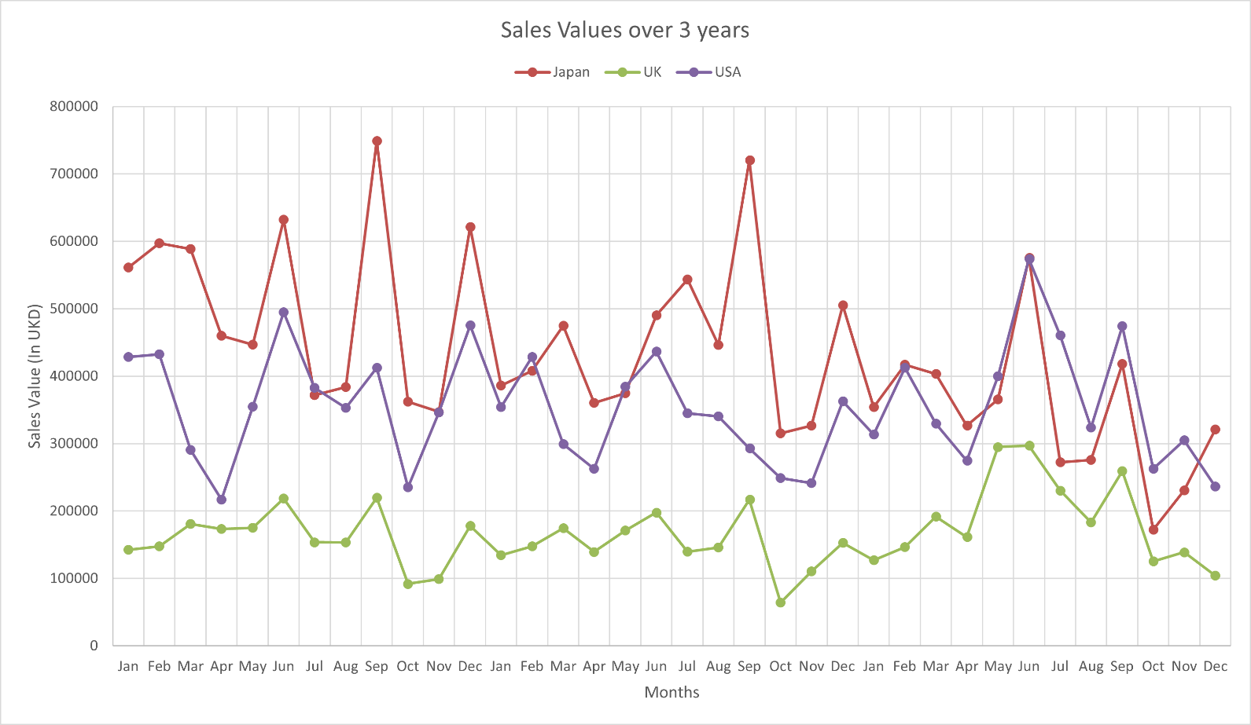

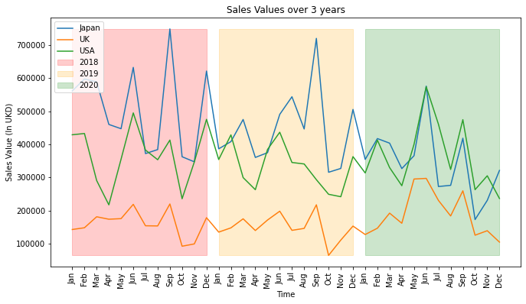

### Chart 2:

* This chart shows sales of categories in different markets for overall period.
* Japan market has highest sales value of hair band among all categories and market. Hair band is least sold in UK.
* Bracelet’s sales values are highest in USA while least in Japan.
* Other categories’ sales values are highest in USA and lowest in UK.

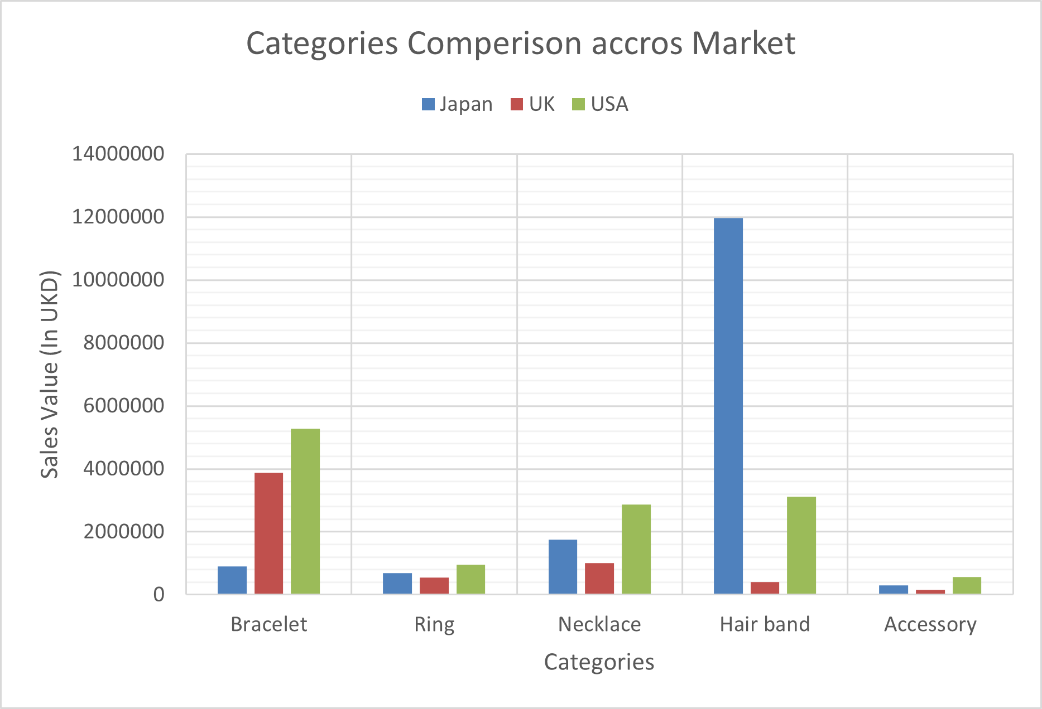

### Chart 3:

* This chart shows sales values of all market for year 2020.
* As we can see that in UK sales values are drastically increase in May and June in compared to April.
* In Japan and USA, sales values are also increase in June in compared to April and May.
* Hence it can be concluded that investment in marketing campaign has positive impact in sales values.

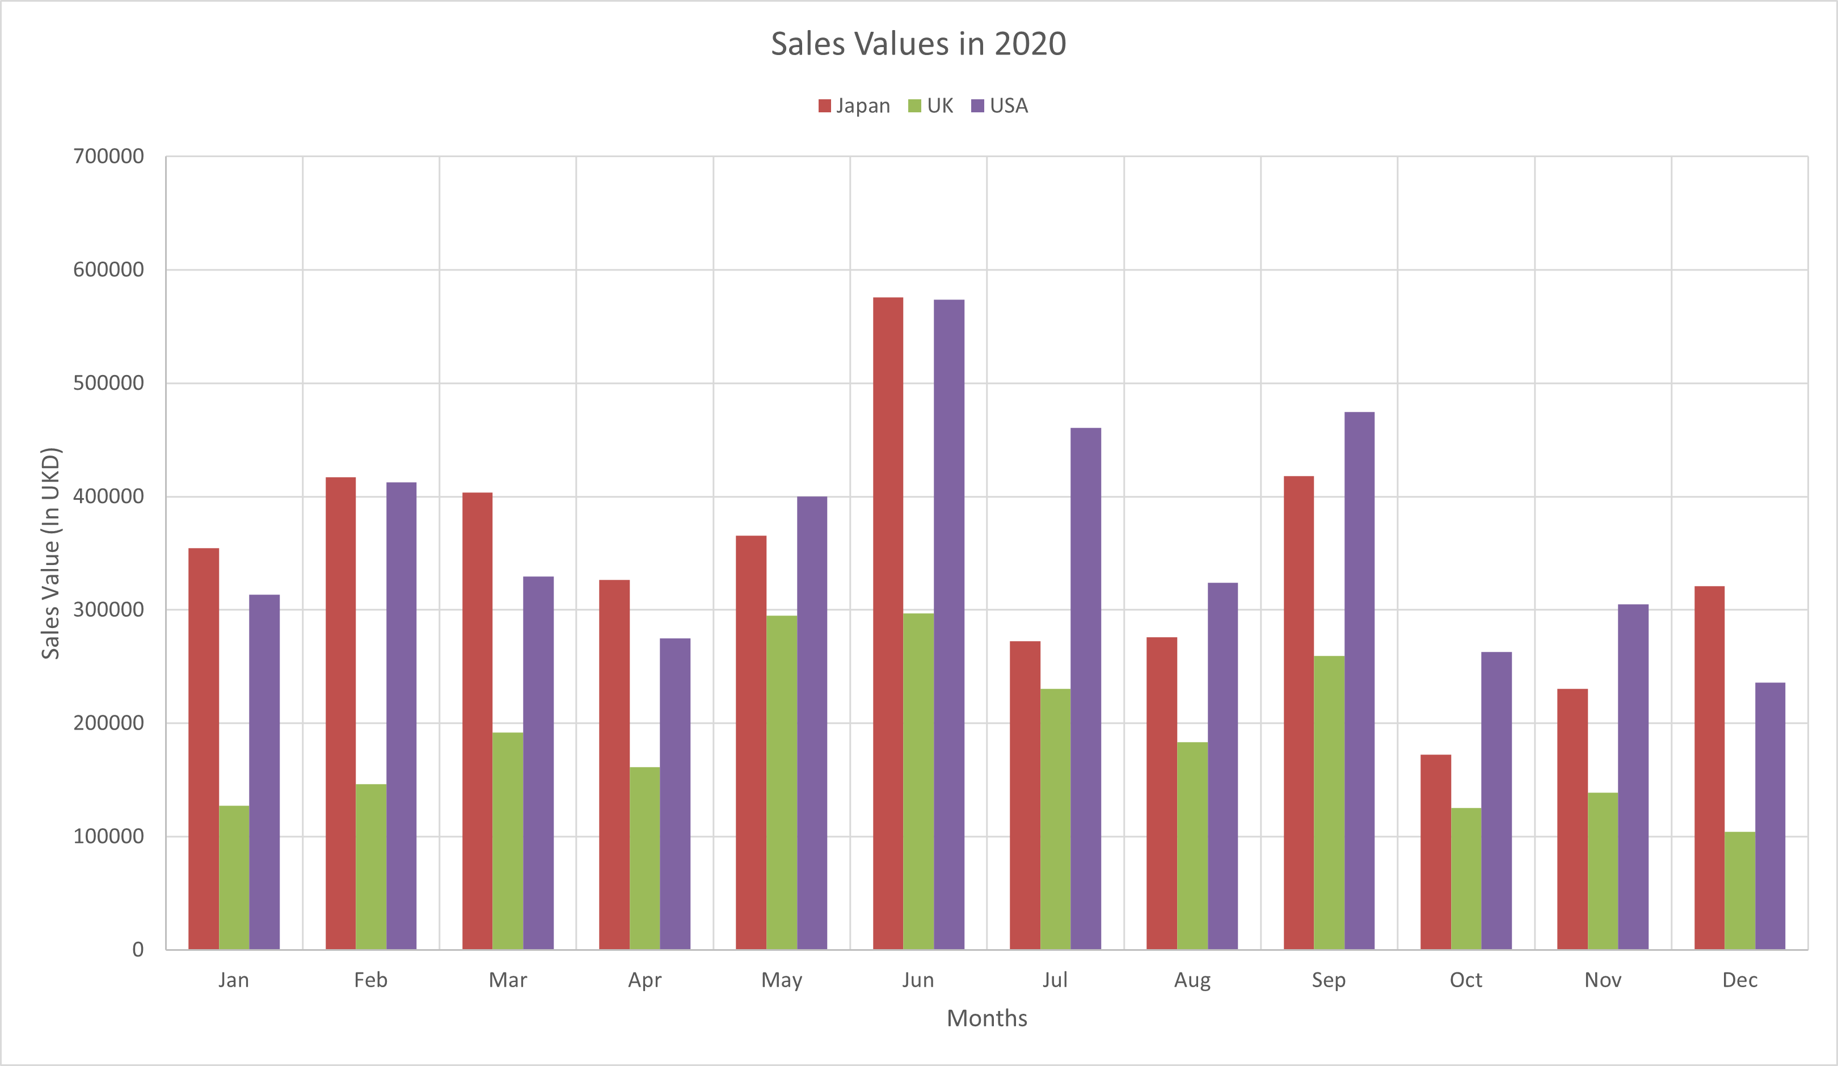

## Conclusion:

* In UK market, highest sale value was in year 2020 while lowest in 2019.
* Bracelet has highest sale values while Accessories has lowest sale values in UK market.
* Investment in marketing campaign has very positive impact not only UK, but in USA and Japan also. The average sales value increased 61.46% due to marketing campaign.
* The sales are generally higher in 2nd quarters with respect to other quarters while in whole period 4th quarter has lowest sale values.
* Accessory had lowest sales in 2018 and 2019, but after marketing campaign its sale increased.

## Recommendations:

* After seeing impact of marketing campaign, it should be noted that if a market has low sales in particular category, there should advertise that category product. For example, company should advertise bracelet in Japan, hair band in UK & USA, Necklace in Japan, and UK.
* There are lower sales in 4th quarter of the year, they should come up with exciting offers and discount in 4th quarter of year to increase sales.

# Bibliography

Eckerson, B.W. and 5.10.2007 (no date) *Predictive Analytics*, *Transforming Data with Intelligence*. Available at: https://tdwi.org/articles/2007/05/10/predictive-analytics.aspx (Accessed: 9 October 2022).

Jones, P. *et al.* (2008) ‘Marketing and sustainability’, *Marketing Intelligence & Planning*, 26(2), pp. 123–130. Available at: https://doi.org/10.1108/02634500810860584.

Kemp, S.E., Hort, J. and Hollowood, T. (2018) *Descriptive Analysis in Sensory Evaluation*. John Wiley & Sons.

Lepenioti, K. *et al.* (2020) ‘Prescriptive analytics: Literature review and research challenges, *International Journal of Information Management*, 50, pp. 57–70. Available at: https://doi.org/10.1016/j.ijinfomgt.2019.04.003.

Marr, B. (2012) *Key Performance Indicators (KPI): The 75 measures every manager needs to know*. Pearson UK.

Soltanpoor, R. and Sellis, T. (2016) ‘Prescriptive Analytics for Big Data’, in M.A. Cheema, W. Zhang, and L. Chang (eds) *Databases Theory and Applications*. Cham: Springer International Publishing (Lecture Notes in Computer Science), pp. 245–256. Available at: https://doi.org/10.1007/978-3-319-46922-5_19.